**Bootstrap - (btn-group, form, tables, search, …)**

* **Form:**

Bootstrap’s form controls expand on [our Rebooted form styles](https://getbootstrap.com/docs/5.0/content/reboot/#forms) with classes. Use these classes to opt into their customized displays for a more consistent rendering across browsers and devices.

Be sure to use an appropriate type attribute on all inputs (e.g., email for email address or number for numerical information) to take advantage of newer input controls like email verification, number selection, and more.

Here’s a quick example to demonstrate Bootstrap’s form styles. Keep reading for documentation on required classes, form layout, and more.

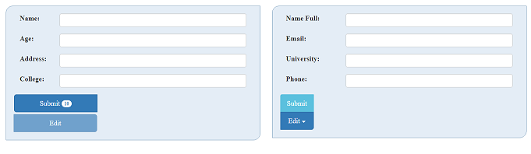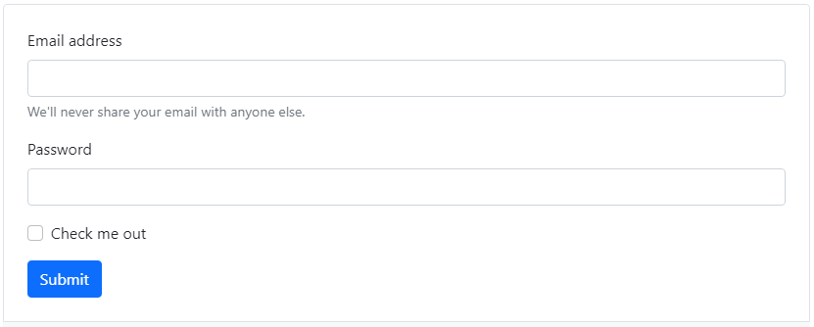

* **Btn-group:**

“Button Groups” in [Bootstrap](https://www.geeksforgeeks.org/bootstrap/) is a class of name “btn-group” which is used to create a series of buttons in groups (without spaces) vertically or horizontally.

Examples:



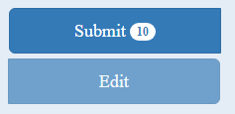



**Syntax:**This is the basic syntax of the button group class where each button has its own class of “btn”**.**

<div class="btn-group">

<button type="button" class="btn">Click</button>

</div>

**Adding Styles on Buttons:**[Bootstrap](https://www.geeksforgeeks.org/bootstrap/) allows you to add styles to your buttons using the following classes:

* .btn-default
* .btn-primary
* .btn-success
* .btn-info
* .btn-warning
* .btn-danger
* .btn-link

**Search:** Bootstrap 5 Search component

The search box is an UI element prepared for creating search engines. Its most important element is search input, but it can also contain icons or buttons. It is also adjusted to be used in various other components such as navbar, dropdown, table, select, sidenav and many more.



## Variations

Search comes with plenty of variations. Choose from the following as needed:

* Search with icon
* Search with button
* Search without additional elements

**Search with table:**

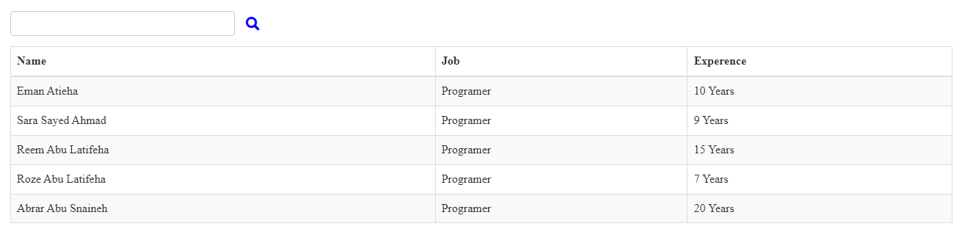

# Alerts

Provide contextual feedback messages for typical user actions with the handful of available and flexible alert messages.

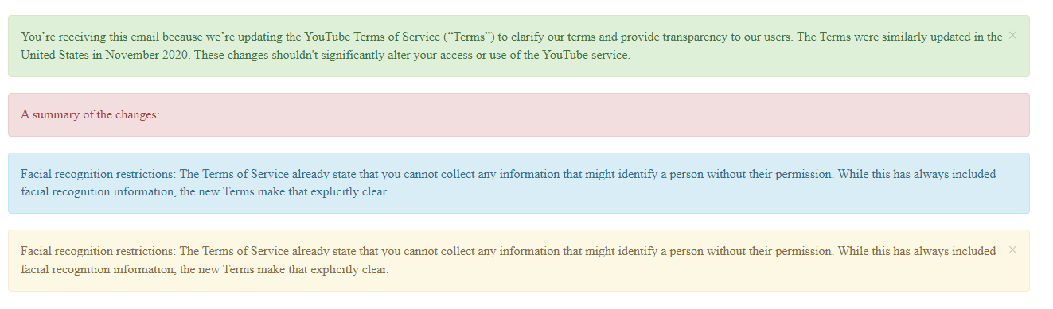

With icons:

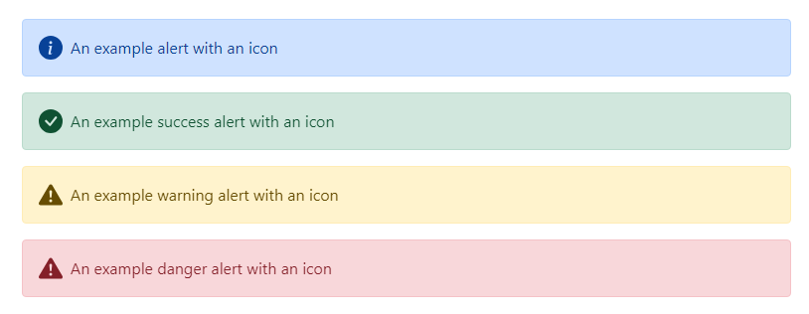

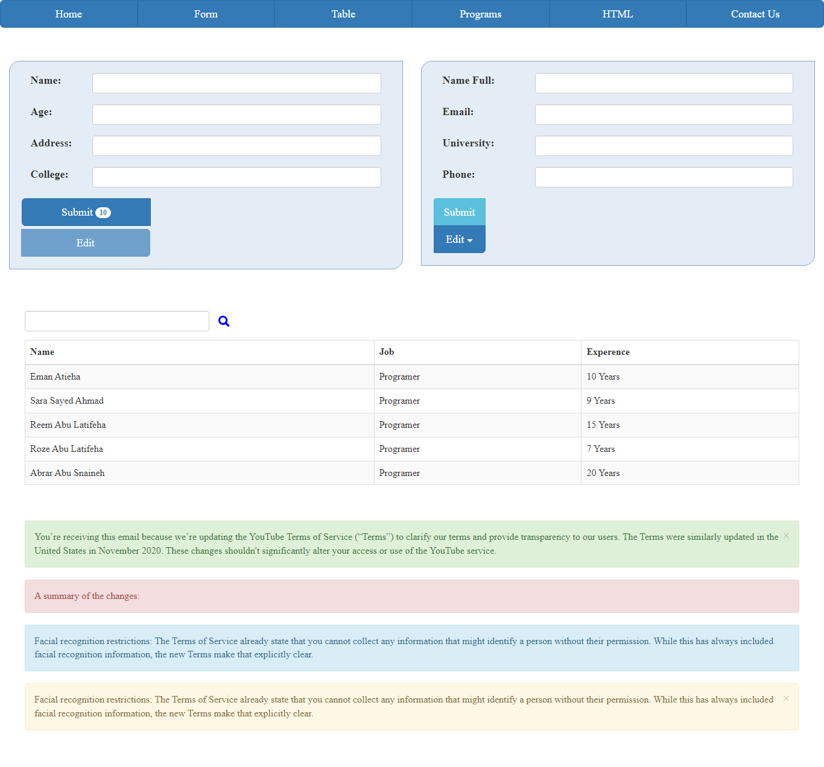Page: